555 Timer Frequency Equations

Introduction

The 555 timer IC (integrated circuit) was a popular oscillator in 1970s because of its ability to:
- generate high frequency square wave signals (astable settings),
- generate step functions (monostable settings),
- produce high current outputs for speakers.

For decades people used to make:
- Sirens and alarms,
- Electronic pianos,
- Button ON/OFF switches (monostable settings),
- Music synthesizers and sound effects,
- Signal generators (square and triangle),
- Timers/square wave oscillators for digital circuits.
with 555 timer ICs.

Today the 555 timer oscillator is still a very popular IC (integrated circuits) for hobby circuit applications.There are also 556 (dual timer) and 558 (quad timer) ICs.

This article is most about the 555 timer frequency calculations.

555 Timer Oscillator (Astable Setting)

You can search for 555 timer oscillator circuits on Google. Those circuits are well known.

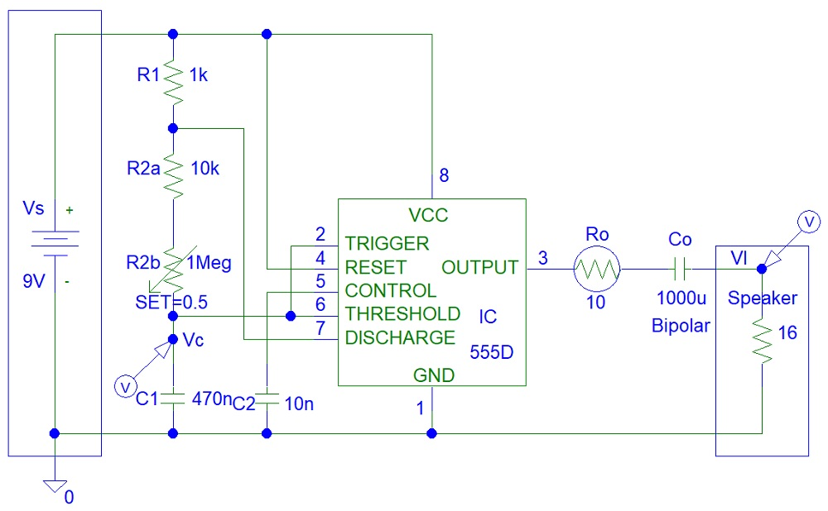
Figure 1: 555 Timer Oscillator

This is how the oscillation cycled works:

Capacitor C1 charges from zero to 2/3 supply voltage
Capacitor C1 discharges from ⅔*Vs voltage to ⅓*Vs because pin 7 short circuit
The 555 timer output changes from almost Vs to almost zero
(Vs = supply voltage)
The 555 timer output changes from almost zero to almost Vs
(Vs = supply voltage)
Capacitor C1 charges from ⅓*Vs voltage to ⅔*Vs because pin 7 is open circuit
Figure 2: 555 Timer Oscillation Cycle

The capacitor, C1 charges via R1, R2a and R2b resistors and discharges via R2a and R2b resistors.

Design the Circuit

You can search the internet for 555 timer oscillator frequency calculations. Those formulas are well known. The frequency of oscillation is equal to:

$f = \frac{1.44}{(R1+2×(R2a+R2b)) × C1)}$
(The resistor and capacitor values are shown in the circuit)

Simulations
You can see in simulations that the capacitor charges from a third of supply voltage to two thirds of supply voltage:
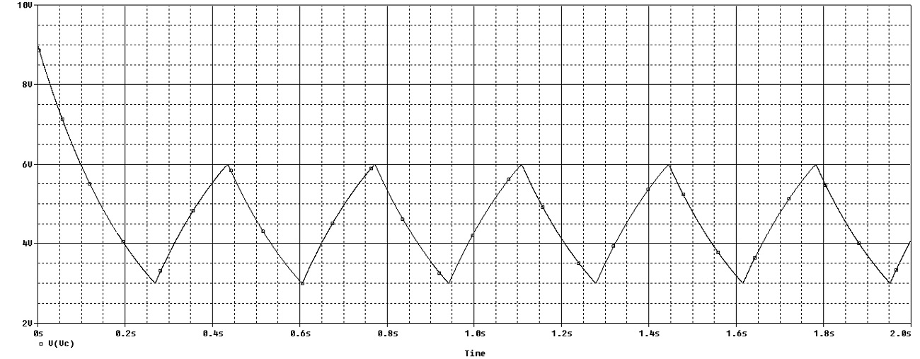
Figure 3: 555 Timer Capacitor Voltage

The square wave output is not ideal in shape because of low speaker impedance (equivalent resistance):
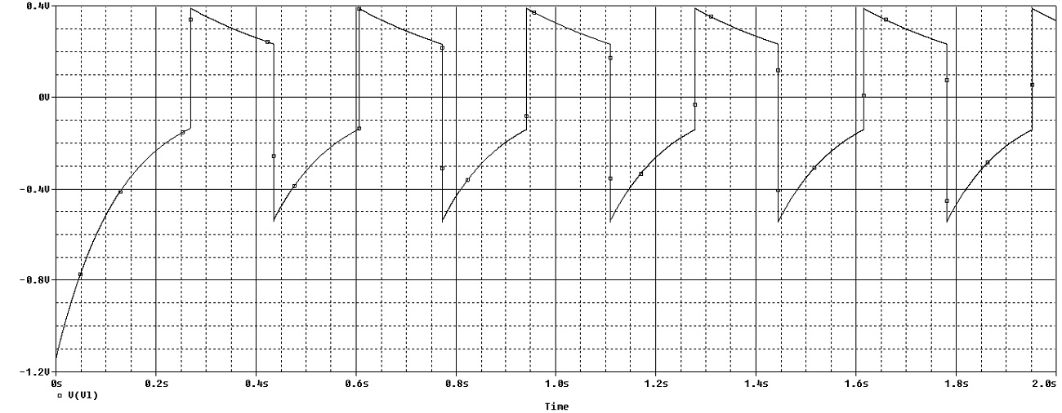
Figure 4: 555 Timer Output Voltage

Monostable Setting

You can search for monostable 555 timer circuits on the internet. Those circuits activate when a button is pressed to lock the timers into a ON state (pin 2 - trigger) until the power supply is turned OFF or the reset pin (pin 4) is set to zero.

The voltage of a charging capacitor versus time is equal to:

$Vc(t)=Vs×(1-exp(-t/τ))$
(Where:$τ=$Charging Time Constant (seconds) = (R1 + R2a + R2b)⨯C1)

The voltage of a discharging capacitor versus time is equal to:

$Vc(t)=Vi×exp(-t/τ)$
(Where: $Vi$= Initial charged voltage (V) = Vs,
$τ=$Discharging Time Constant (seconds) = (R2a + R2b)⨯C1)

Oscillator/Astable Setting Equations

Now we can proof the frequency equation shown earlier in this article:

Capacitor C1 charge period:

T1 / TimeConstant1 = ln(⅔*Vs) - ln(⅓*Vs)
(Where: T1 = Capacitor charging period (seconds)
TimeConstant1 = Charging Time Constant = (R1 + R2a + R2b)⨯C1)

T1 / TimeConstant1 = (ln(Vs) + ln(⅔)) - (ln(Vs) + ln(⅓))
= ln(⅔) - ln(⅓)
= ln((⅔)/(⅓))
T1 = ln(2/1)⨯TimeConstant1

T1 = 0.693147181⨯TimeConstant1
T1 = 0.693147181⨯(R1 + R2a + R2b)⨯C1

= ln(2)⨯(R1 + R2a + R2b)⨯C1
Capacitor C1 discharge period:

T2 / TimeConstant2 = ln(2)
(Where: T2 = Capacitor discharging period (seconds)
TimeConstant2 = Charging Time Constant = (R2a + R2b)⨯C1)

T2 = 0.693147181⨯(R2a + R2b)⨯C1
= ln(2)⨯(R2a + R2b)⨯C1

Total oscillation cycle period:

T1 + T2 = 0.693147181⨯(R1 + 2⨯(R2a + R2b))⨯C1
= ln(2)⨯(R1 + 2⨯(R2a + R2b))⨯C1

$f = \frac{1}{ln(2)×(R1+2×(R2a+R2b)) × C1)}$
$= \frac{1}{0.693147181×(R1+2×(R2a+R2b)) × C1)}$
$= \frac{1.44269504}{(R1+2×(R2a+R2b)) × C1)}$

You can refer to references about division of logarithms.

Conclusion

Now you can see why the 555 timer IC is a useful circuit. However, nowadays there are many voltage controlled oscillator ICs. The most popular is the 8038 IC that can generate triangular, square wave and sinusoidal signals that 555 timers cannot generate.

References

https://www.circuitbasics.com/555-timer-basics-monostable-mode/

https://www.wikihow.com/Divide-Logarithms
- https://en.wikipedia.org/wiki/Intersil_ICL8038
- https://en.wikipedia.org/wiki/555_timer_IC

